Project: Moffat Bay
Course: CSD 460
Description: Tests for the Attractions page
Date: 09/24/2026
To complete the test case plan, fill out the information for Project, Course, Description and Date in the header below.
.
TABLE OF CONTENTS
Attractions Page Loads with Hero Content and Working Navigation 1
Attractions Page Displays All Activity Cards with Correct Content and Attribution 2

For each test, the developer should: provide a test description, a test objective, the developer name and date tested. For each step, fill out the actions to be taken and describe the expected results, and indicate yes or no for each step depending upon the result. The peer tester should provide their name, date tested, indicate yes or no for each step depending upon the result, and a screenshot (thumbnail) of the result.

Test 1 | Attractions Page Loads with Hero Content and Working Navigation
 | Test Objective:  Verify page loads as a static page, displays the correct hero content, and that its navigation links and menu toggle point to and work correctly | Developer: Brayan Covarrubias  Date tested: 2026/09/24 | Peer tester: Tiffany Davidson  Date tested: 2026/09/26
Step | Action | Expected results: | Developer pass/fail | Tester pass/fail  + Screenshot
1 | Start the dev server and navigate to http://127.0.0.1:8000/attractions.html | The page loads with no console errors, tab title reads “Attractions | Moffat Bay Lodge” and heading displays “Island Adventures Await” with aerial photo rendered. | Pass | Pass  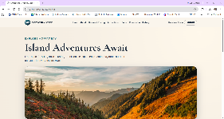
2 | Inspect the main navigation bar at the top of the page | Ensure all 6 links are in order – Home, About, Rooms & Pricing, Attractions, Book, Reservation History (if logged in) | Pass | Pass  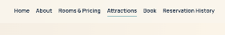
3 | Narrow browser viewport (or window) below mobile breakpoint and click on hamburger menu toggle button | The main navigation becomes visible in vertical format | Pass | Pass  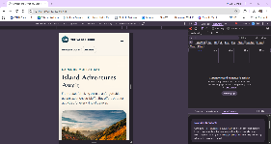
4 | On mobile menu open, click any navigation link (ex. about.html) | Ensure the menu closes and navigates to about.html and loads content appropriately | Pass | Pass  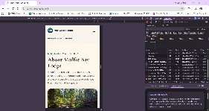
5 | Navigate back to attractions.html and check the #auth-chip element in header | Ensure the chip renders either “Login/Register” links or “Welcome/Logout” depending on login status | Pass | Pass  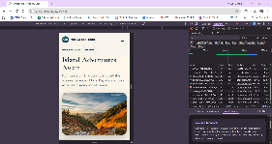
Comments | I tested the Attractions page in both desktop and mobile views. The hero content, navigation, mobile menu, and account links displayed and worked as expected. I did not find any navigation or layout issues during testing.

Test 2 | Attractions Page Displays All Cards with Correct Content
 | Test Objective:  Verify the “Experience the Island” activity grid renders all four static activity cards with their correct images, titles, description, and category tags. | Developer: Brayan Covarrubias  Date tested: 2026/09/24 | Peer tester: Tiffany Davidson  Date tested: 2026/09/26
Step | Action | Expected results: | Developer pass/fail | Tester pass/fail
1 | Start the dev server and navigate to http://127.0.0.1:8000/attractions.html | The page loads to attractions.html with no broken UI elements | Pass | Pass  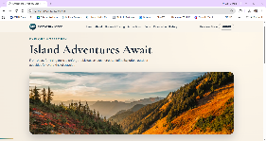
2 | Scroll down and read the title and category tag of each card in order | In order from left to right – “Hiking” with “Land Adventure”, “Kayaking” with “Water Adventure”, “Whale Watching” with “Wildlife Adventure”, and “Scuba Diving” with “Ocean Adventure” | Pass | Pass  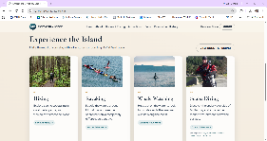
3 | Check each card image and ensure they have a descriptive alt text | All four images successfully rendered and each has an alt attribute describing the picture shown. | Pass | Pass  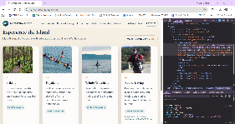  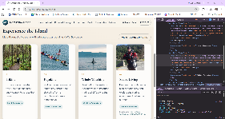  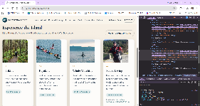  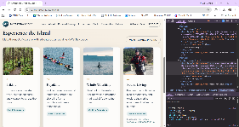
4 | View image credit for Scuba Diving card | Ensure proper image credit is addressed to Riley Huntley | Pass | Pass  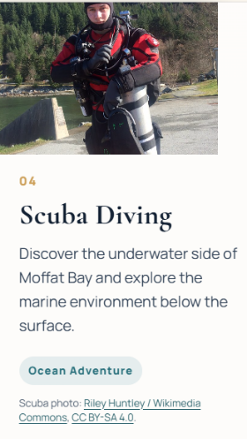
Comments | All four attraction cards displayed with the correct content and images. The images included descriptive alt text, and the Scuba Diving image included the required Riley Huntley credit. I did not find any broken images or missing content during testing.

Project: | Moffat Bay Lodge
Course: | CSD 460
Description: | Testing the functionality of our Attractions page
Date: | 2026/09/27
To complete the test case plan, fill out the information for Project, Course, Description and Date in the header below.
.
TABLE OF CONTENTS
Verify Attractions Page 2
Verify Attractions Page Buttons & Links in Desktop Mode 3
Verify Attractions Page Buttons & Links in Mobile Mode 4

For each test, the developer should: provide a test description, a test objective, the developer name and date tested. For each step, fill out the actions to be taken and describe the expected results, and indicate yes or no for each step depending upon the result. The peer tester should provide their name, date tested, indicate yes or no for each step depending upon the result, and a screenshot (thumbnail) of the result.
Test 1 | Verify Attractions Page
 | Test Objective: | Developer: Rashai Robertson  Date tested: 2026/09/27 | Peer tester: Tiffany Davidson  Date tested: 2026/09/26
Step | Action | Expected results: | Developer pass/fail | Tester pass/fail  + Screenshot
1 | Open the Attractions page. | The Attractions page loads successfully and displays the page header and content. | Pass | Pass  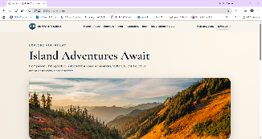
2 | Review the attraction cards. | Hiking, Kayaking, Whale Watching, and Scuba Diving are displayed. | Pass | Pass  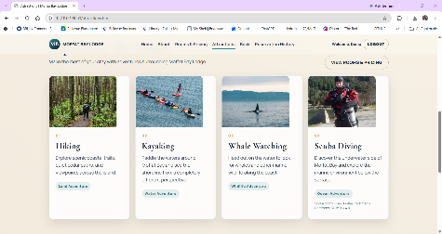
3 | Review the images for each attraction. | Each attraction image loads correctly without broken images. | Pass | Pass  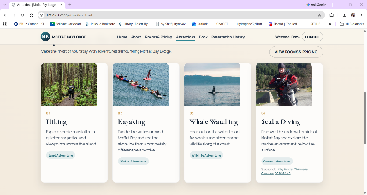
4 | Review the attraction descriptions. | Each attraction displays its appropriate description and activity type. | Pass | Pass  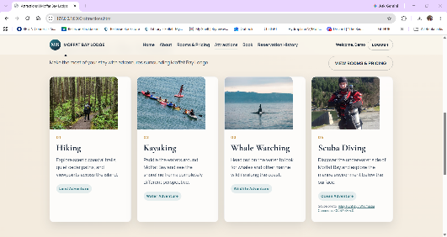
Comments | The Attractions page loaded correctly and all four activities displayed with their images, descriptions, and activity types. I also checked the page at different screen sizes and did not find any broken images or layout problems.

Test 2 | Verify Attractions Page Buttons & Links in Desktop Mode
 | Test Objective: Ensure that all clickable links and buttons work. | Developer: Rashai Robertson  Date tested: 2026/09/27 | Peer tester: Tiffany Davidson  Date tested: 2026/09/26
Step | Action | Expected results: | Developer pass/fail | Tester pass/fail  + Screenshot
1 | Load attractions.html | attractions.html loads | Pass | Pass  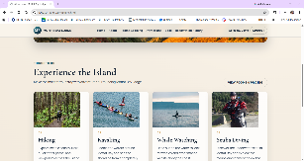
2 | Click ‘Home’ | Index.html loads | Pass | Pass  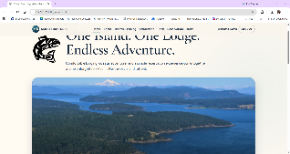
3 | Click ‘About’ | About.html loads | Pass | Pass  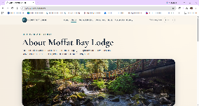
4 | Click ‘Rooms & Pricing’ | Rooms.html loads | Pass | Pass  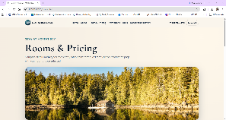
5 | Click ‘Attractions’ | Attractions.html loads | Pass | Pass  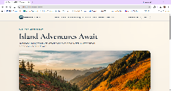
6 | Click ‘Book’ | Reservation.html loads | Pass | Pass  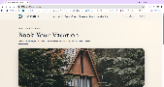
7 | Click ‘Login’ | Login.html loads | Pass | Pass  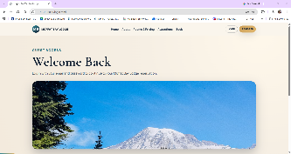
8 | Click ‘Register’ | Register.html loads | Pass | Pass  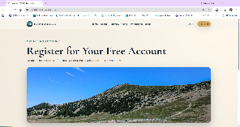
9 | Click the ‘View Rooms & Pricing’ button | Rooms.html loads | Pass | Pass  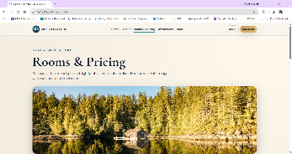
10 | Click ‘Reserve Your Room’ | Reservation.html loads | Pass | Pass  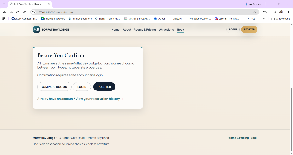
11 | Click ‘Compare Rooms’ | Rooms.html loads | Pass | Pass  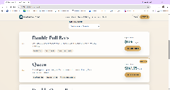
12 | Click ‘Rooms & Pricing’ in the footer | Rooms.html loads | Pass | Pass  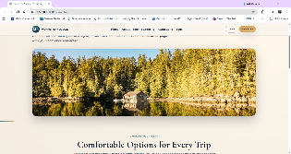
13 | Click ‘Book in the footer | Reservation.html loads | Pass | Pass  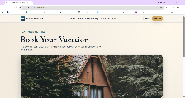
14 | Click ‘Moffat Bay Lodge in the header | Index.html loads | Pass | Pass  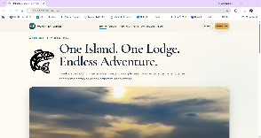
Comments | Rashai: All links work in desktop mode.  Tiffany: I tested each navigation link and call-to-action from the Attractions page in desktop view. Every link opened the expected page and I did not encounter any broken links or unexpected redirects.

Test 3 | Verify Attractions Page Buttons & Links in Mobile Mode
 | Test Objective: Ensure that all clickable links and buttons work on mobile widths. | Developer: Rashai Robertson  Date tested: 2026/09/27 | Peer tester: Tiffany Davidson  Date tested: 2026/09/26
Step | Action | Expected results: | Developer pass/fail | Tester pass/fail  + Screenshot
1 | Load attractions.html | attractions.html loads | Pass | Pass  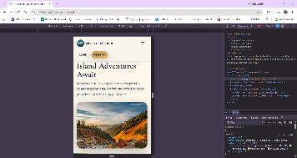
2 | Click ‘Moffat Bay Lodge in the header | Index.html loads | Pass | Pass  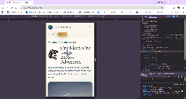
3 | Click ‘Login’ | Login.html loads | Pass | Pass  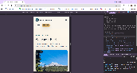
4 | Click ‘Register’ | Register.html | Pass | Pass  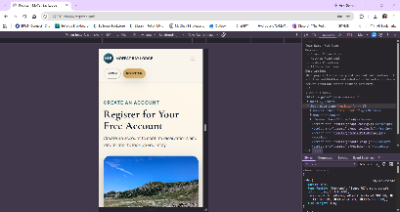
5 | Click the mobile menu | The mobile menu reveals the menu links | Pass | Pass  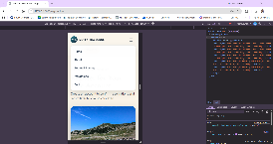
6 | Click ‘Home’ | Index.html loads | Pass | Pass  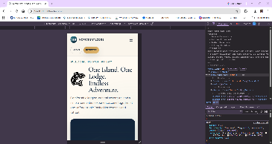
7 | Click ‘About’ | About.html loads | Pass | Pass  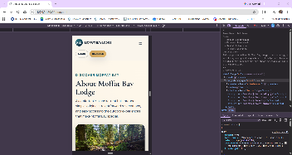
8 | Click ‘Rooms & Pricing’ | Rooms.html loads | Pass | Pass  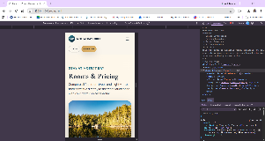
9 | Click ‘Attractions’ | Attractions.html loads | Pass | Pass  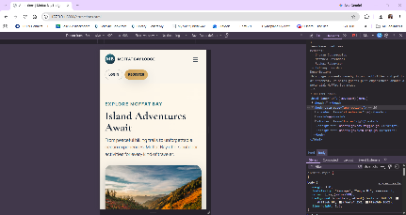
10 | Click ‘Book’ | Reservation.html loads | Pass | 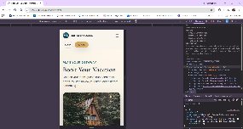
11 | Click ‘Login’ | Login.html loads | Pass | Pass  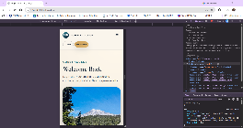
12 | Click ‘Register’ | Register.html loads | Pass | Pass  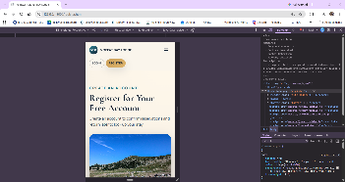
13 | Click the ‘View Rooms & Pricing’ button | Rooms.html loads | Pass | Pass  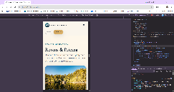
14 | Click ‘Reserve Your Room’ | Reservation.html loads | Pass | Pass  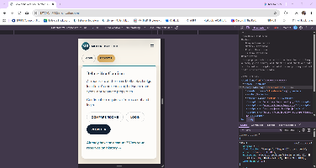
15 | Click ‘Compare Rooms’ | Rooms.html loads | Pass | Pass  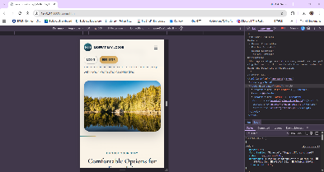
16 | Click ‘Rooms & Pricing’ in the footer | Rooms.html loads | Pass | Pass  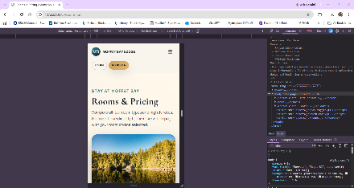
17 | Click ‘Book in the footer | Reservation.html loads | Pass | Pass  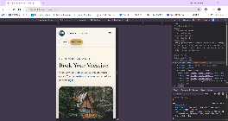
Comments | Rashai: Previously, the mobile menu did not work on the attractions page while it did work on the index. This was fixed and now all links work.  Tiffany: I tested the Attractions page at a mobile screen width, including the hamburger menu and all navigation links. The menu opened correctly and each link loaded the expected page. I did not find any mobile navigation issues during testing.

